# AI-Powered Module Creation Q&A

Contents

AI-Powered Module Creation Q&A 1

Overview 1

End to end Process 2

Create New Module- Authoring from Repo folder (Self-Publishing) 2

Create New Module - Authoring in a folder (no correct Repo connection was set up) (Self-publishing) 8

Update Module from Repo folder (Self-publishing) 12

Update Module from AI-Powered Module Directly 15

Create New Module- Authoring from Repo folder (Pub2Learn ) 19

Create New Module - Authoring in a folder (Pub2Learn) 27

Update Module from Repo folder(Pub2Learn) 32

Update Module from AI-Powered Module (Pub2Learn ) 37

Authoring Tips 42

Q: Are preview-only Learn docs supported as source documents ? 42

Q: How to rename a Module folder ? 42

Q: When updating a module with manually added unit, like 2a-new.md to avoid redirection. How to insert a unit manually in tools ? 45

## Overview

In this document, we have listed the most common questions and scenarios encountered by the author when using AI Powered Module Creation, along with their respective solutions.

## End to end Process

### Create New Module- Authoring from Repo folder (Self-Publishing)

Below is the end-to-end process for using AI-Powered Module Creation to perform a Direct Publish.

Let’s assume you will publish a course to <https://github.com/MicrosoftDocs/learn-dynamics-pr>/

1. Go to Target Repo in Github, say, [learn-dynamics-pr](https://github.com/MicrosoftDocs/learn-dynamics-pr). Click “Fork” to for repo in your own account.

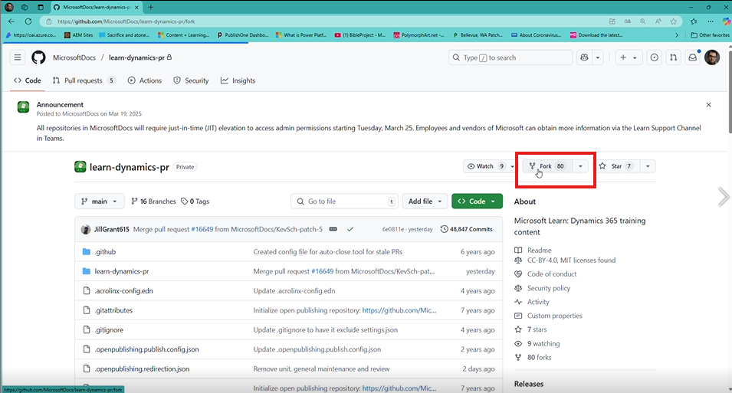

1. Make sure the Owner account, and branch you want to copy, then Click “Create fork”.

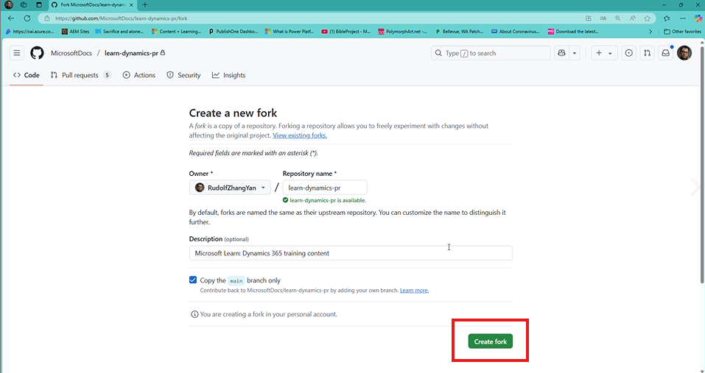

1. Copy your GitHub Repo link (e.g. https://github.com/*Youraccount*/learn-dynamics-pr) .

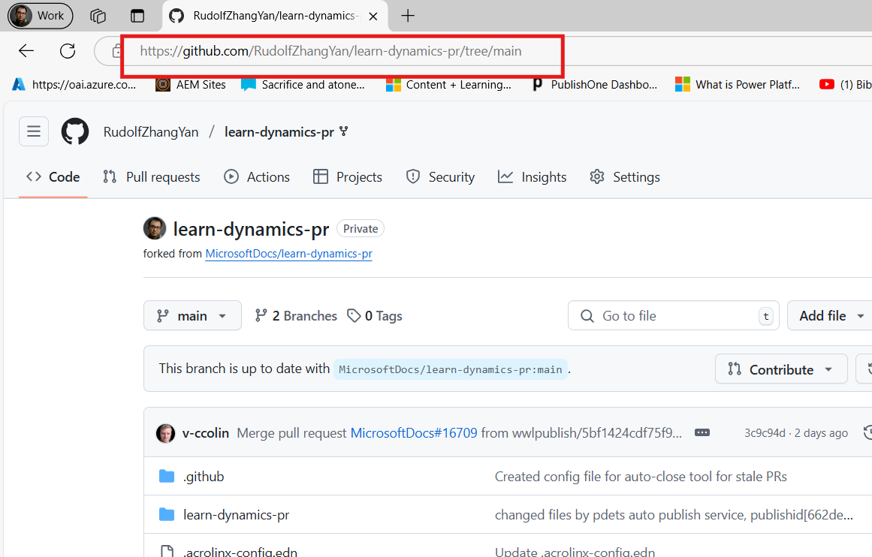

1. Open VSCode. Click “Explorer” icon, then click “Clone Repository”.

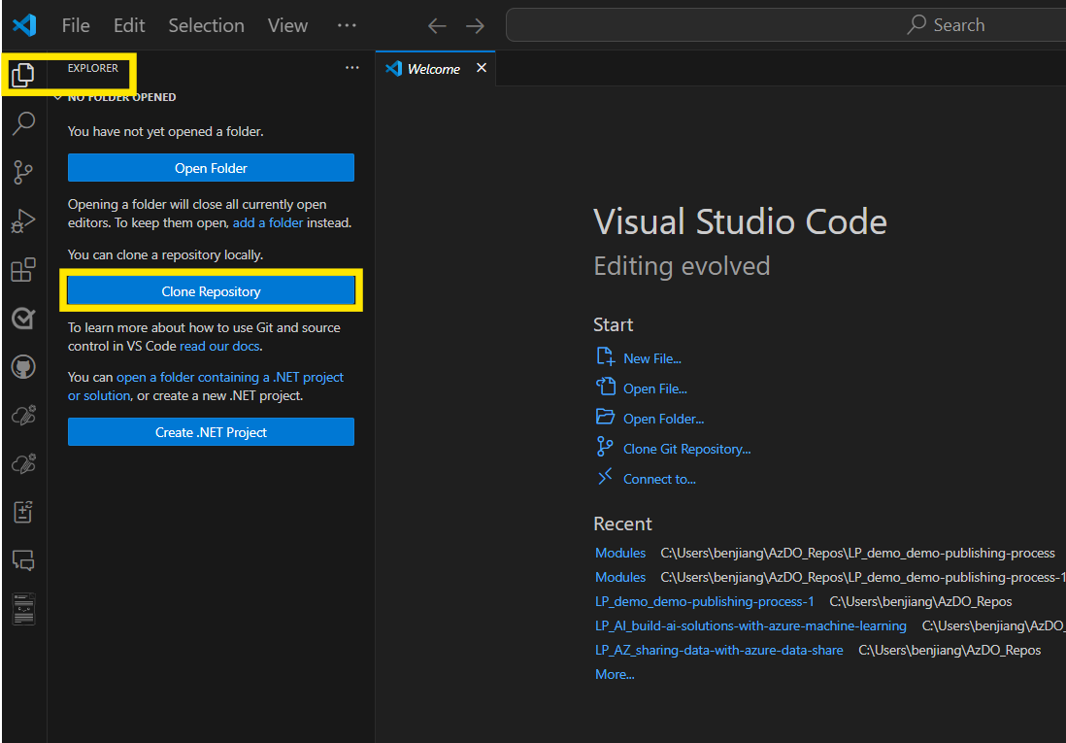

1. And input Git URL. Press enter to clone repository to your local folder.Press enter。When finished Clone. Open in New window.  
   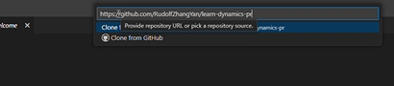
2. After finished cloning repository, you’ll need to do some initialization works.  
   Click Terminal ->New Terminal. Input below git command

Git remote add upstream *<Docs git url>*

This will help you have connection with source Repo

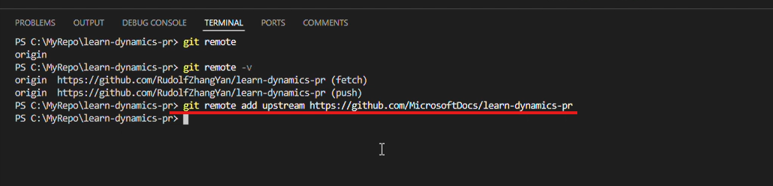

You can run git remote -v to verify connection created.

1. Pull from Upstream. In VS Code click source control icon and select “…”àPull,PushàPull from. Select upstream to pull from. This will ensure your local repo sync with upstream repo  
   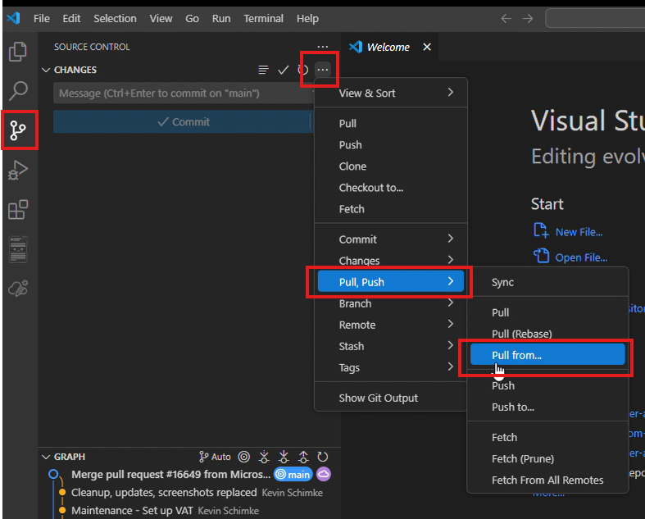

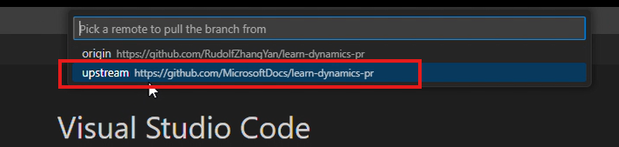

1. Create your own branch. Click “Main” at the bottom of the screen.

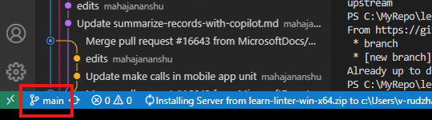

Then select Create new branch to create your own working branch,and input your branch name.

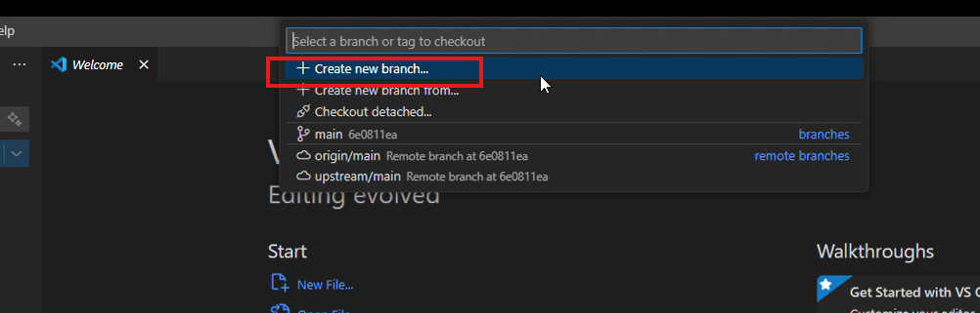

After that your branch has been switched to working branch.

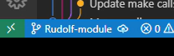

1. Launch AI-Powered Module Creation! Click **Create a new module from scratch**.

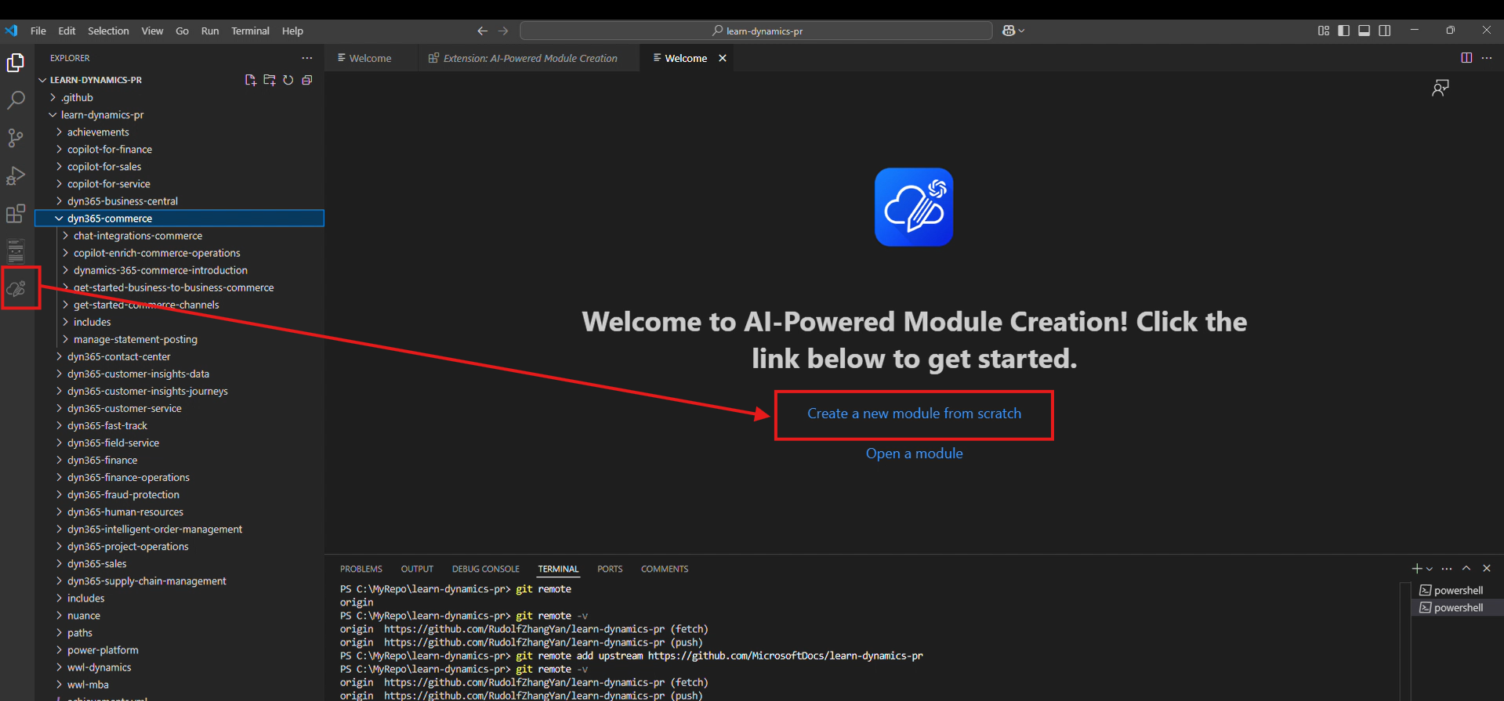

Select your parent folder of your module.

1. Create your new module with extension.

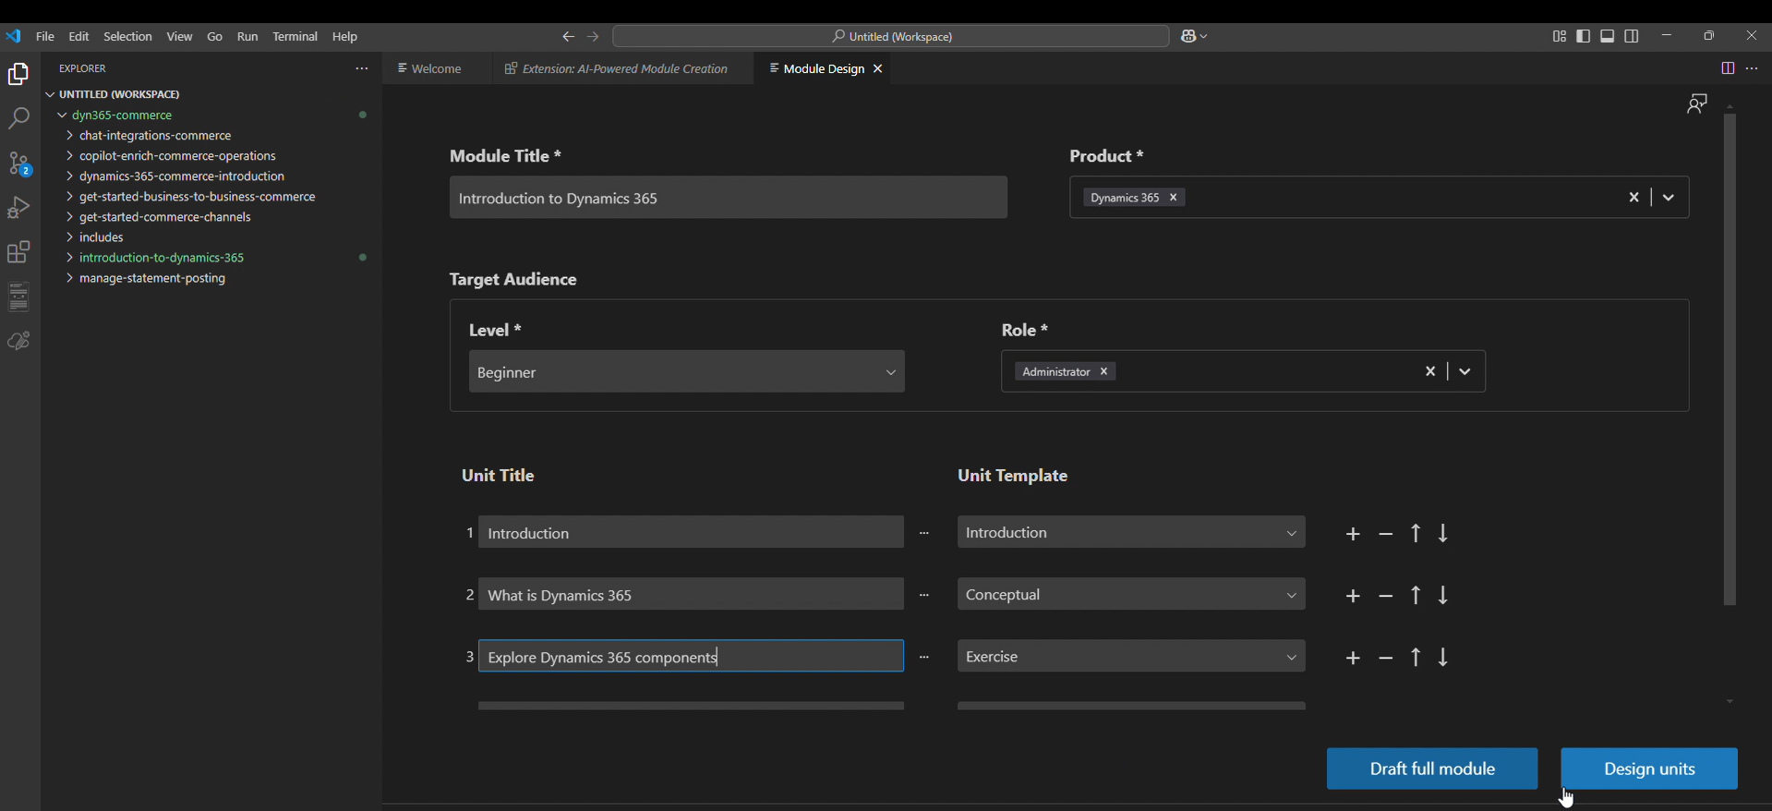

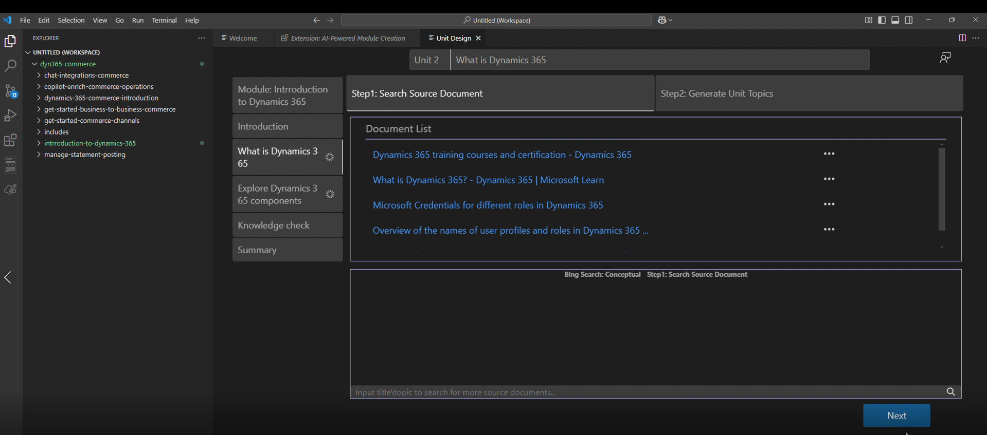

1. Switch to Source Control

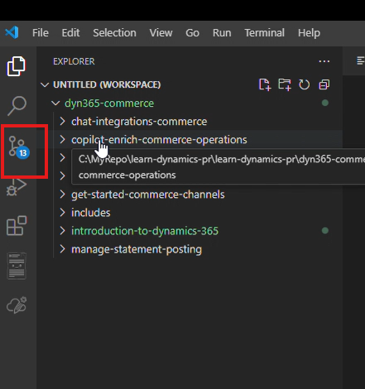

Commit your changes

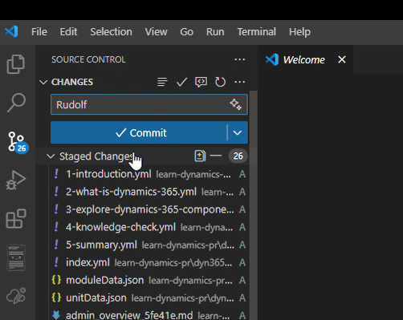

Publish the branch

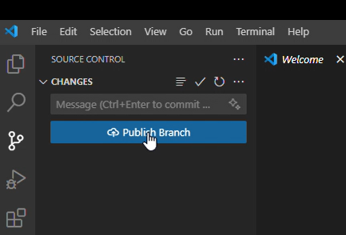

1. Go back to Github and then you can initial Pull request to publish your module.  
   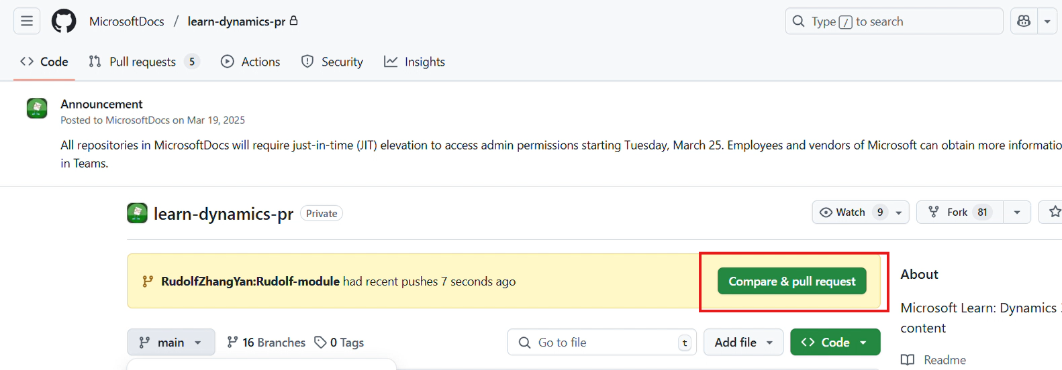

### Create New Module - Authoring in a folder (no correct Repo connection was set up) (Self-publishing)

1. Authoring Module in individual local folder

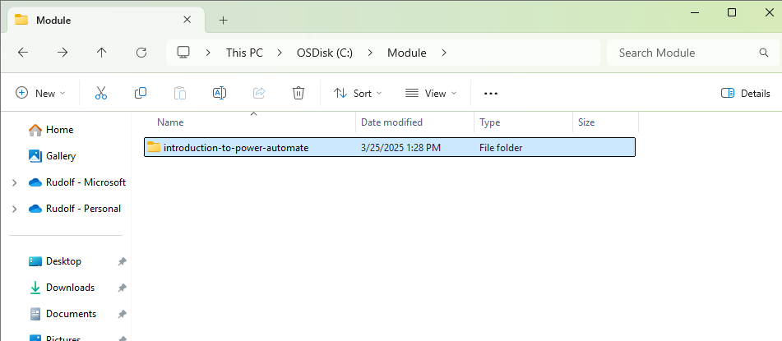

1. Open VS code. Click Explorer icon and then click Open folder.

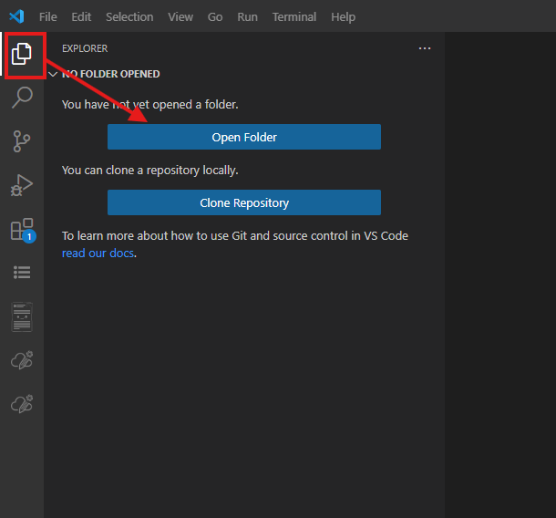

1. In pop-up window,select Repo folder. And click Select Folder.

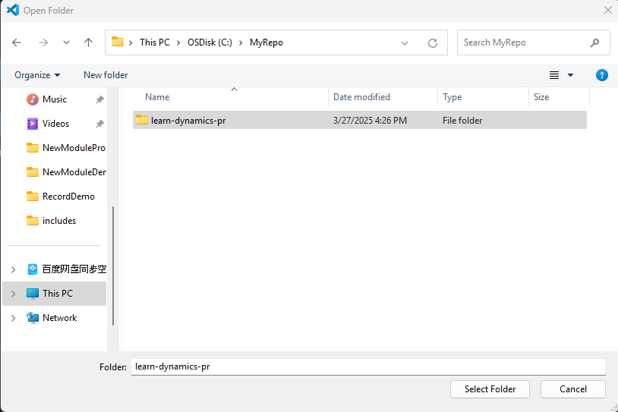

1. Check Branch ensure the branch is the working branch you work with. If it isn’t your working branch. You can click branch name to switch to your working branch.

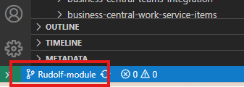

1. Expand folder. Locate to the folder you want to copy modules.Right-click folders and select **Reveal in File Explorer**.

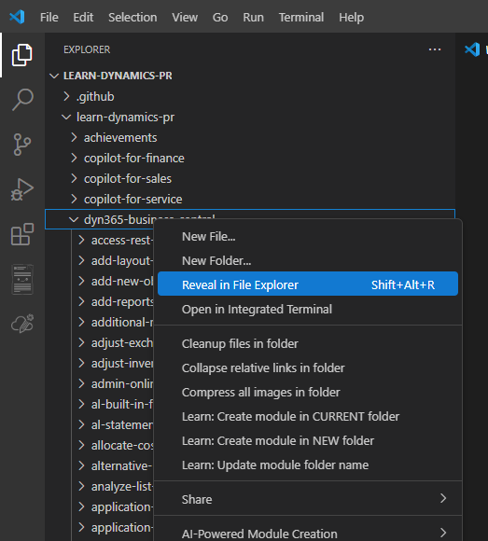

1. Copy module folder into destination folder.

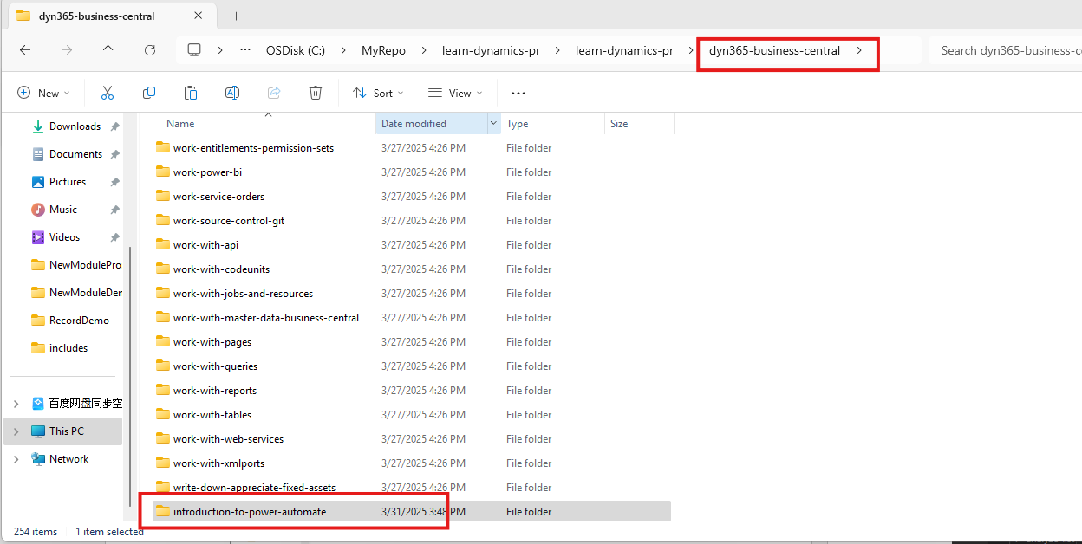

1. Go back to VS Code.Click Source Control, type in comments and click commit button.Commit changes of your new module to git repo

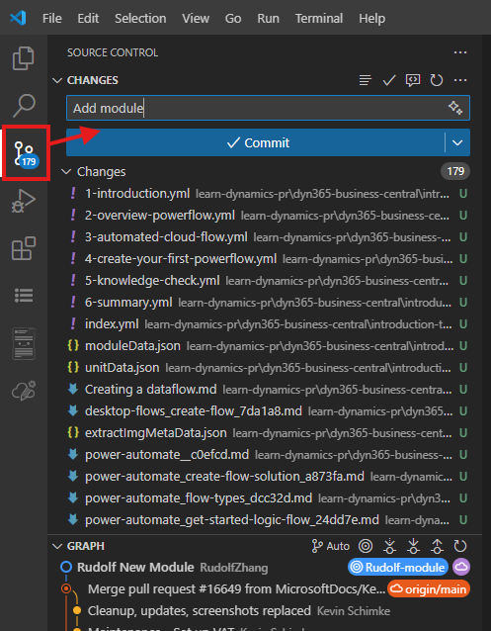

1. Click Sync Changes sync things to Remote Repo

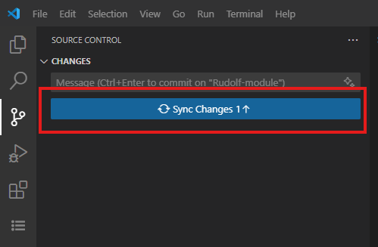

1. Go to your repo initial pull request to publish your content to github repo.

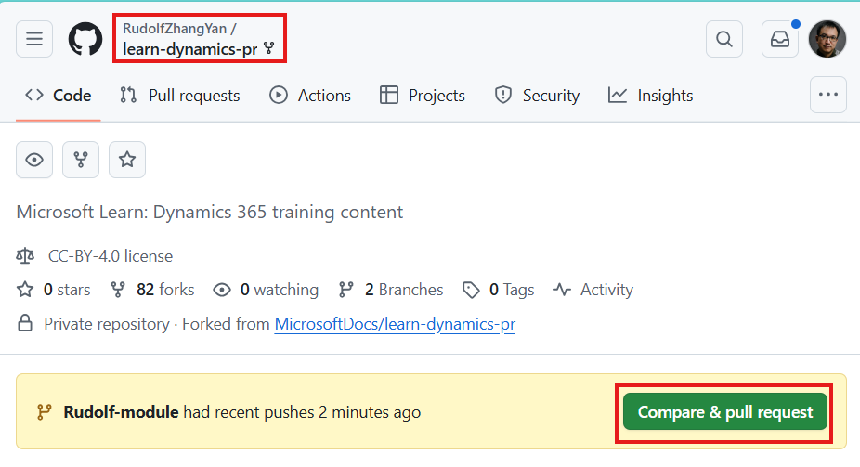

### Update Module from Repo folder (Self-publishing)

1. Clone Learn Repo to local. Right click the Module you want to open. Select AI-Powered Module CreationàOpen a module

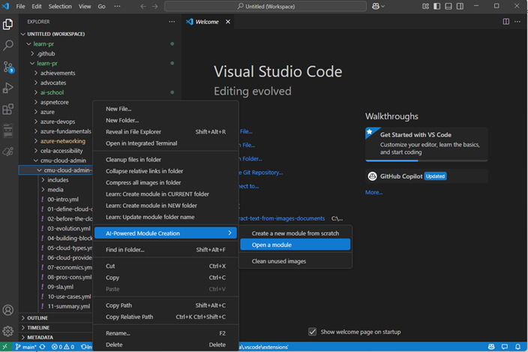

1. System will prompt that it is the extension will create profile for your module. Click **OK** to start this process.

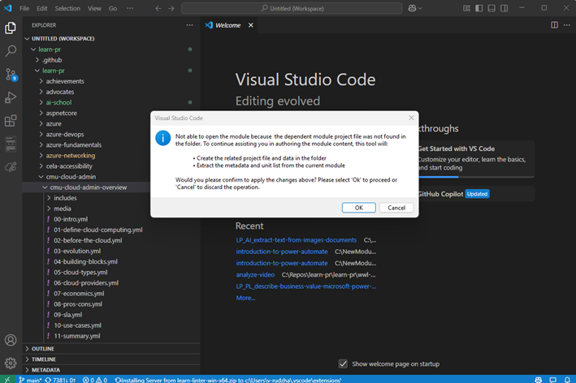

1. You will enter Module Designer.

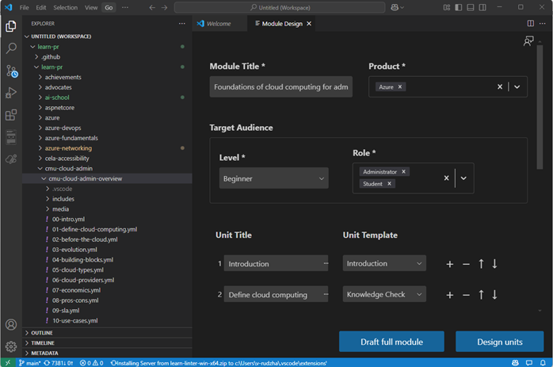

1. Click **Design Units**. You will see all units in generated status. If you want to regenerate a Unit. You could manually add datasource and Unit topics to draft a unit. Or if you want to revise a unit, just close Module designer and then open specific Unit. Then you can revise content with extension’s Content Refine Assistant.

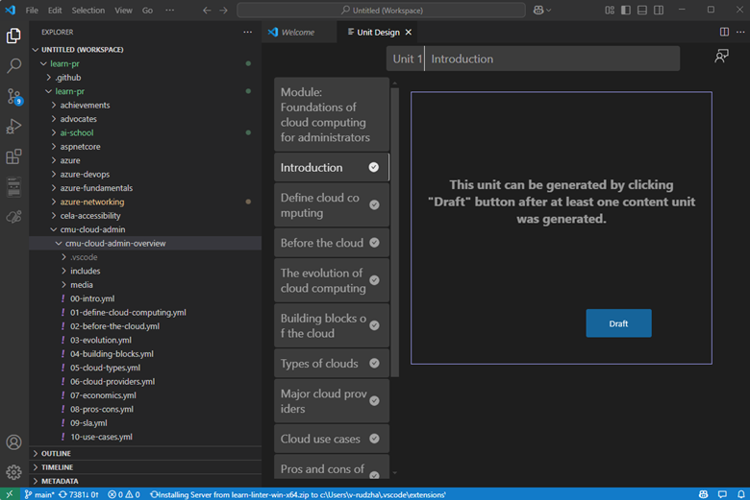

1. After all editing is done, you can continue with the Direct Publishing process.

### Update Module from AI-Powered Module Directly

Sometimes you might want to start editing module folder insider local repo folder directly. Rather than add whole repo into VS Code. To do this you need to follow below steps.

1. Open VS Code, Click Manage (Gear icon) and click Settings.

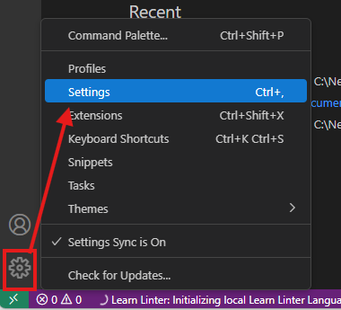

1. Type in git.open and you will see a control Git:open Repository folders.

Select **always**. This will ensure VS Code edit always seek git configuration even if you open partial folder of whole repo

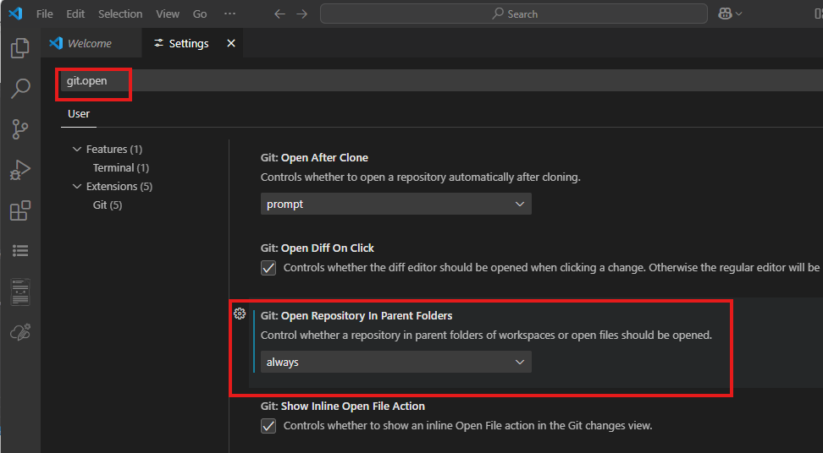

1. Open Extension and click **Open a Module**.

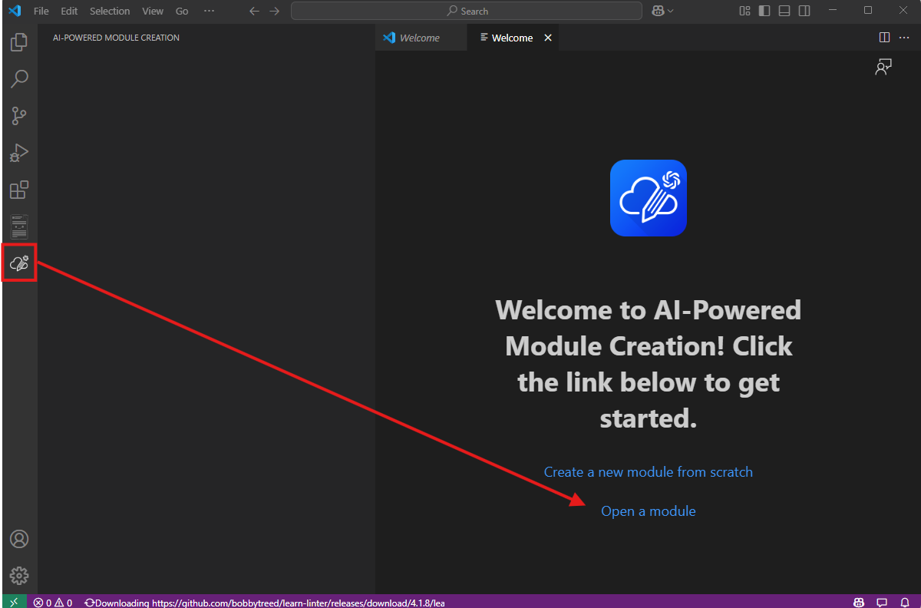

1. System will pump out **Please select the Module folder** dialogue box. Click folder and click **Open**.

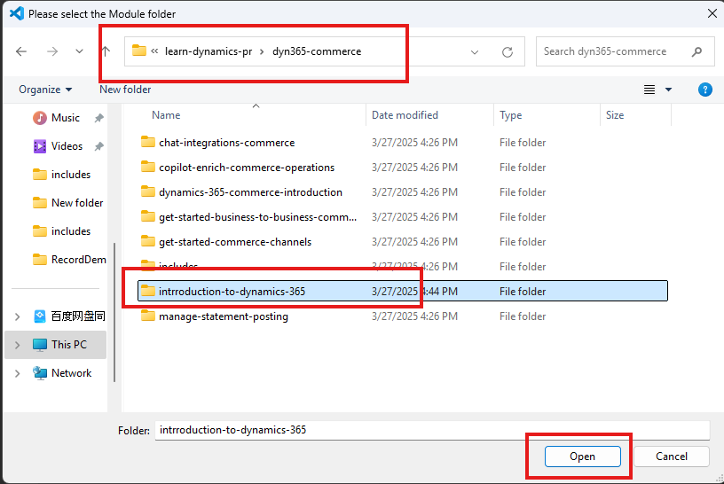

1. You can do any editing works,

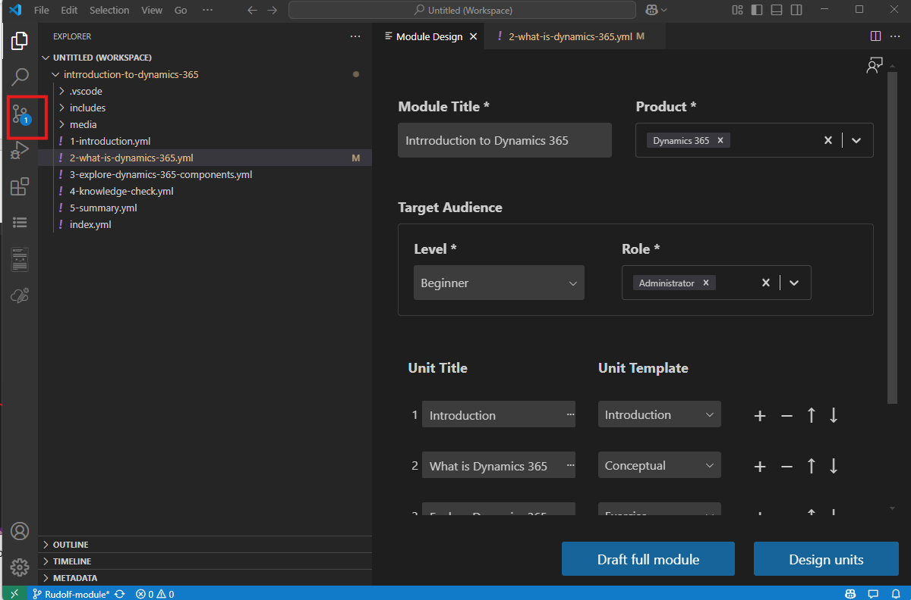

And you can find any editing works will be recorded by Git Repo. Just commit and sync. You will publishing changes to remote repo.

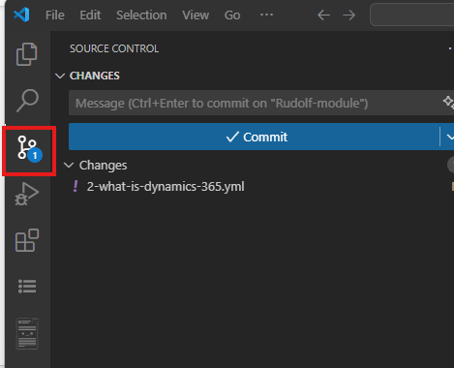

### Create New Module- Authoring from Repo folder (Pub2Learn )

Below is the end-to-end process for using AI-Powered Module Creation to perform a Pub2Learn Publish.

1. Go toPub2learn repo. Click… and then select Clone.

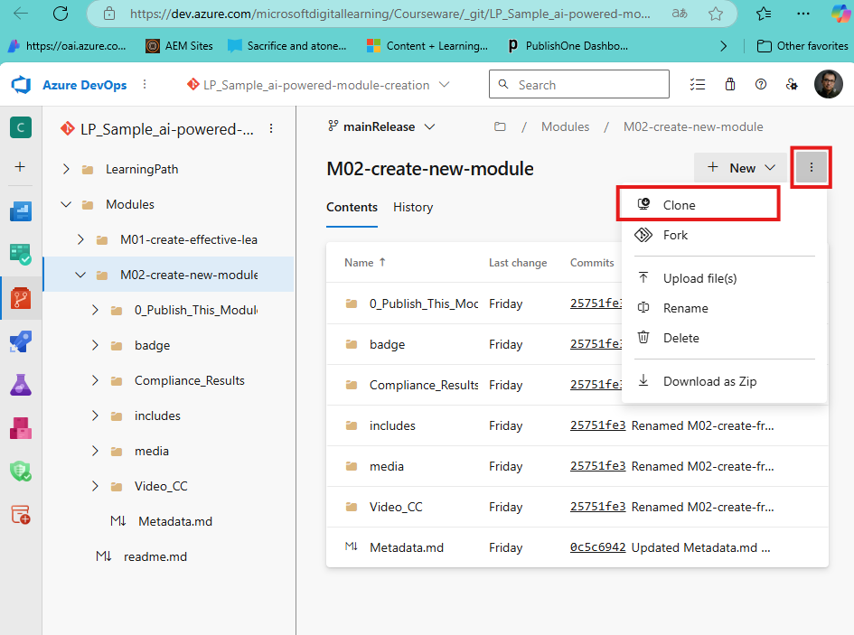

1. And then click Clone in VS code.

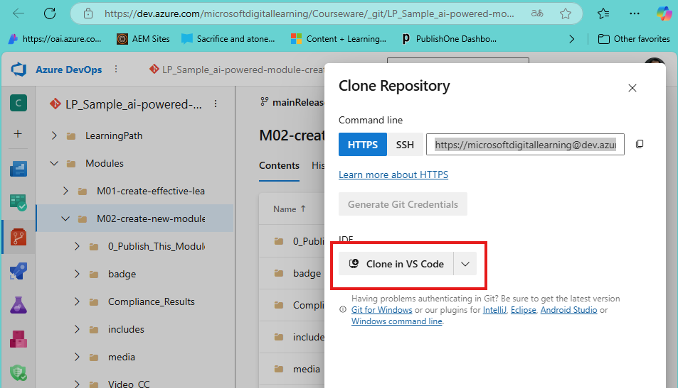

1. Then click “Open”

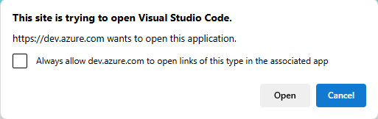

1. In Open dialogue box. Select target folder and click Select as Repository Destination.

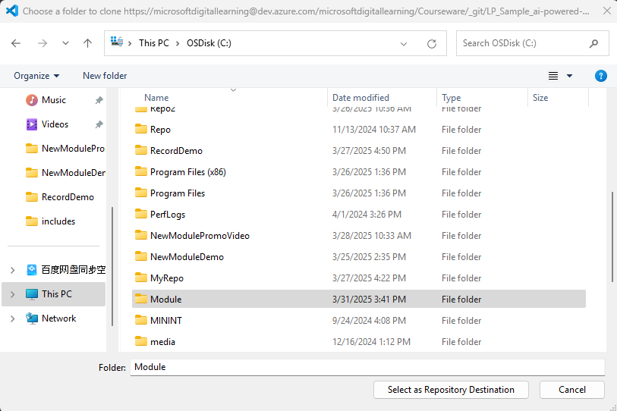

1. Sometimes you will get warning said “Authentication failed”. Then just clone again. System will ask for authentication. Click your account to authenticate.

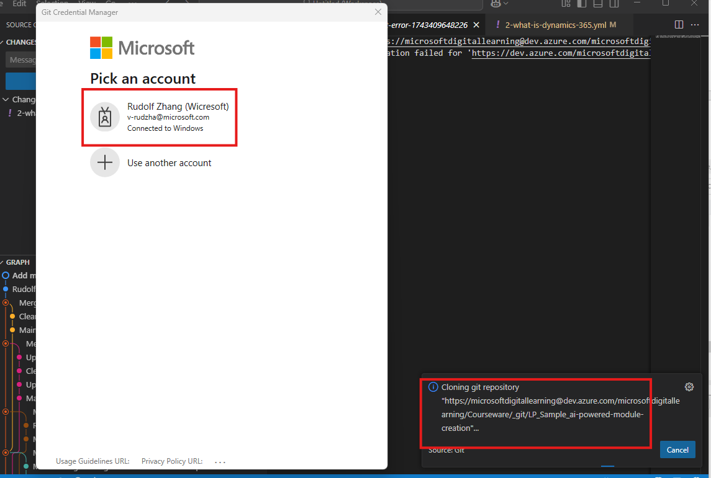

1. When clone finished, system will pump up a window. Click “Open in New Window”.

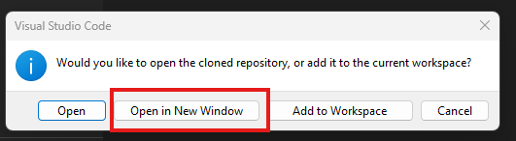

1. First make sure you are in correct branch. You can see from left corner. The correct working branch should be “mainRelease”.If it is not the case ,click branch name and then you can select branch.

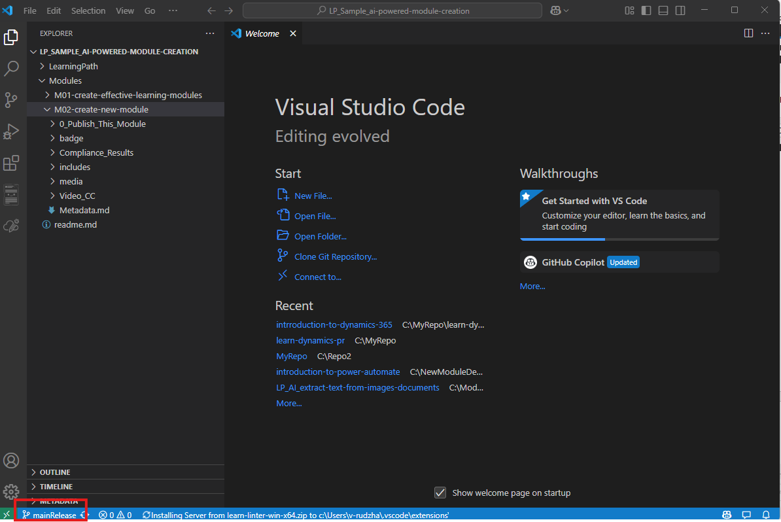

1. Right click Modules folder and select AI-Powered Module Creationà Open a module.

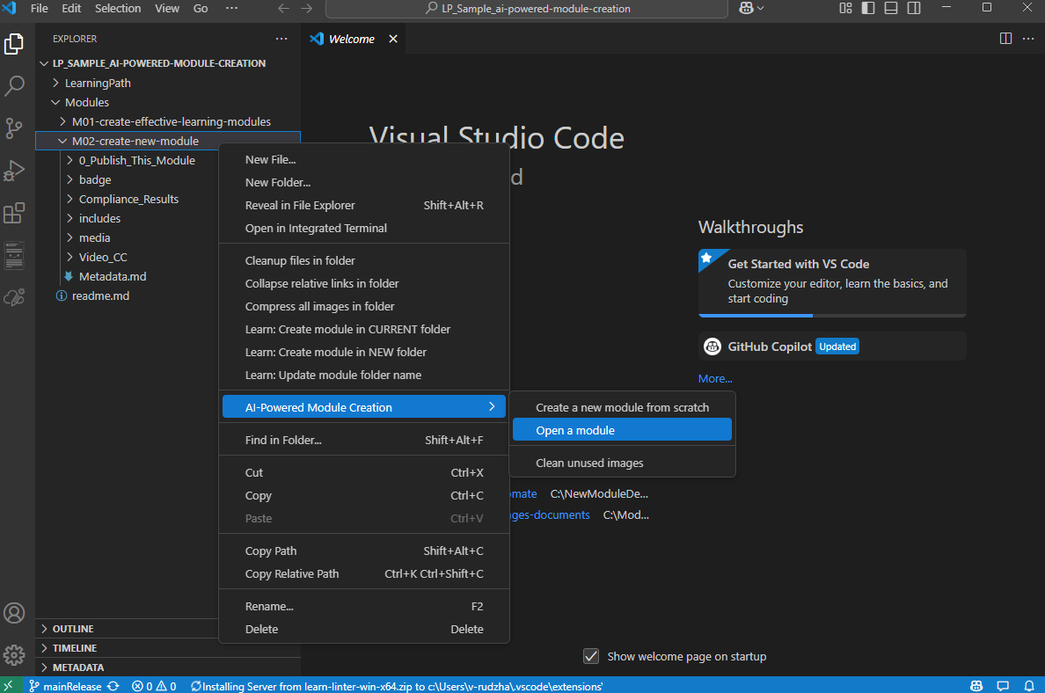

1. System will pump out dialogue box ask for create project files. Click OK.

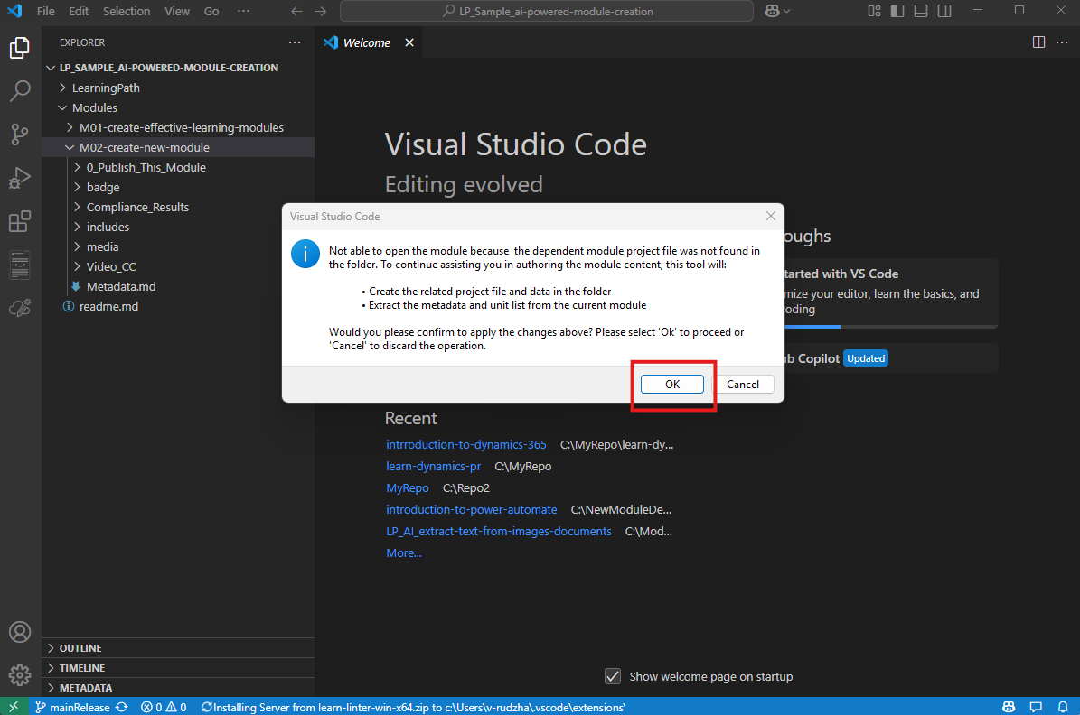

1. Fill in the missing information. And then you can start to edit modules.

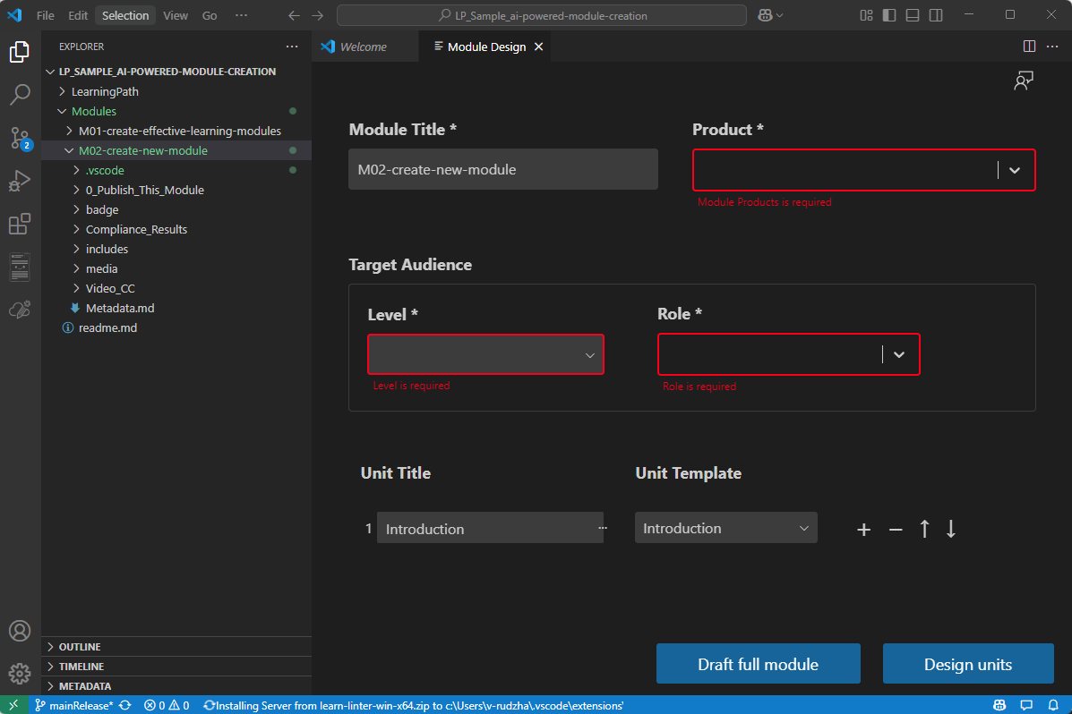

1. Click Source control, you will see changes made in module.

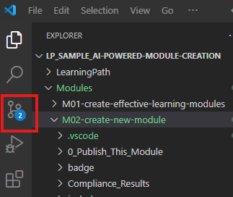

1. Click Source control, you will see changes made in module. Add comments and click commit to commit changes.

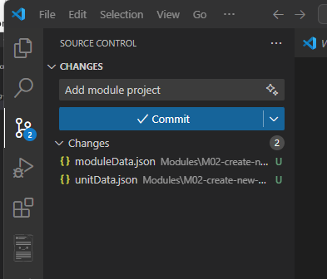

1. Type in information and Click Sync Changes. Your change will be synced to remote repo.

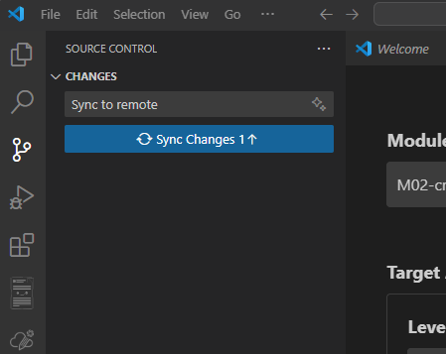

1. When all things done .You can launch publishing from Remote repo.

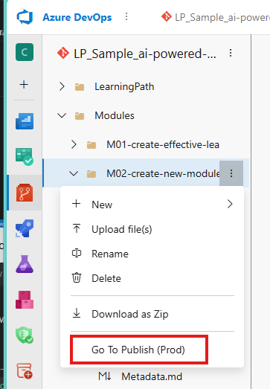

### Create New Module - Authoring in a folder (Pub2Learn)

1. Authoring Module in a folder.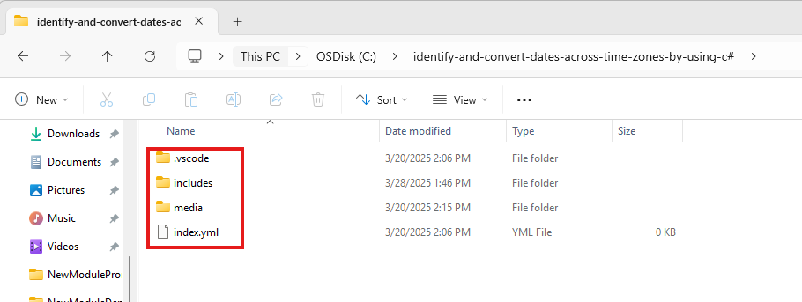
2. Open VS code. Click Explorer icon and then click Open folder.



1. In pop-up window, select Repo folder. And click Select Folder.

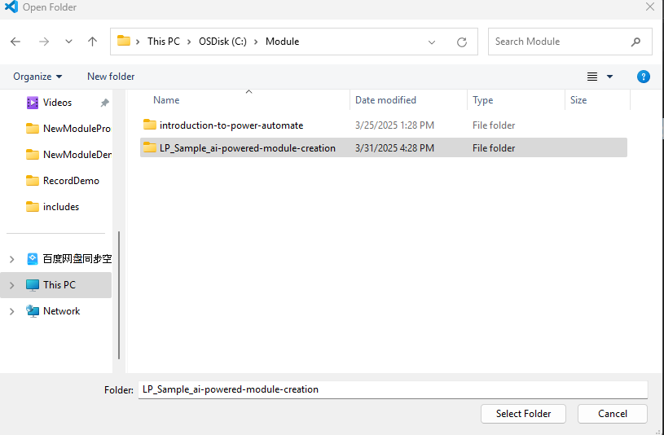

1. Check Branch ensure the branch is the working branch you work with. If it isn’t your working branch. You can click branch name to switch to your working branch.

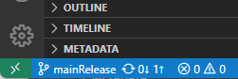

1. Expand folder. Locate to the folder you want to copy modules. Right-click folders and select **Reveal in File Explorer**.

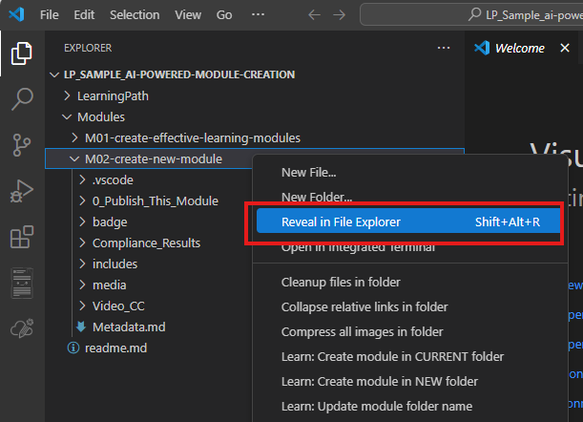

1. Paste Module content into a Repo folder and select Replace the file in the destination.

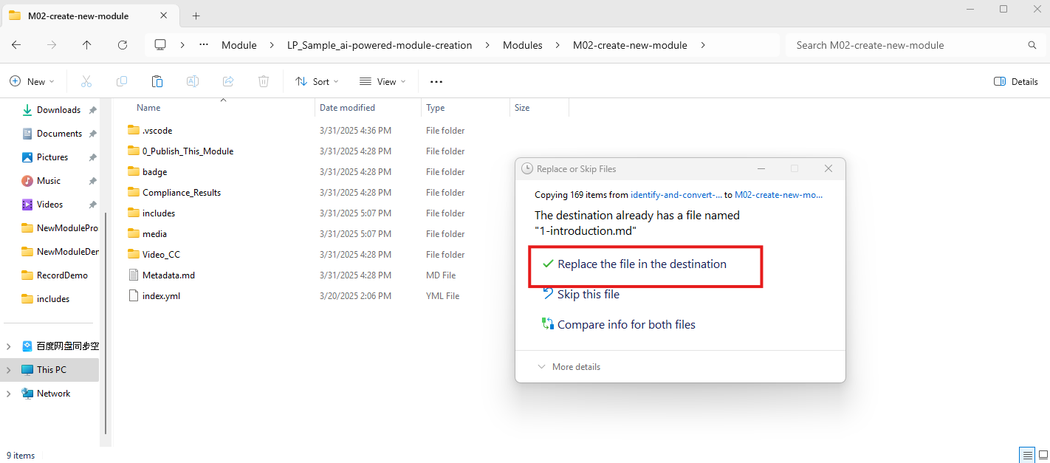

1. Go back to VS Code. Click Source Control, type in comments and click commit button. Commit changes of your new module to git repo

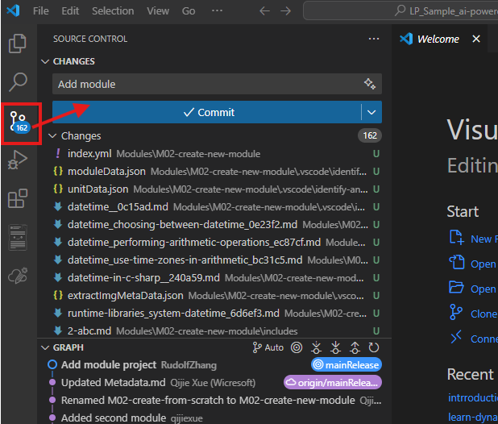

1. Click Sync Changes sync things to Remote Repo



1. When all things done .You can launch publishing from Remote repo.



### Update Module from Repo folder(Pub2Learn)

1. Clone Pub2learn Module to local via VS Code

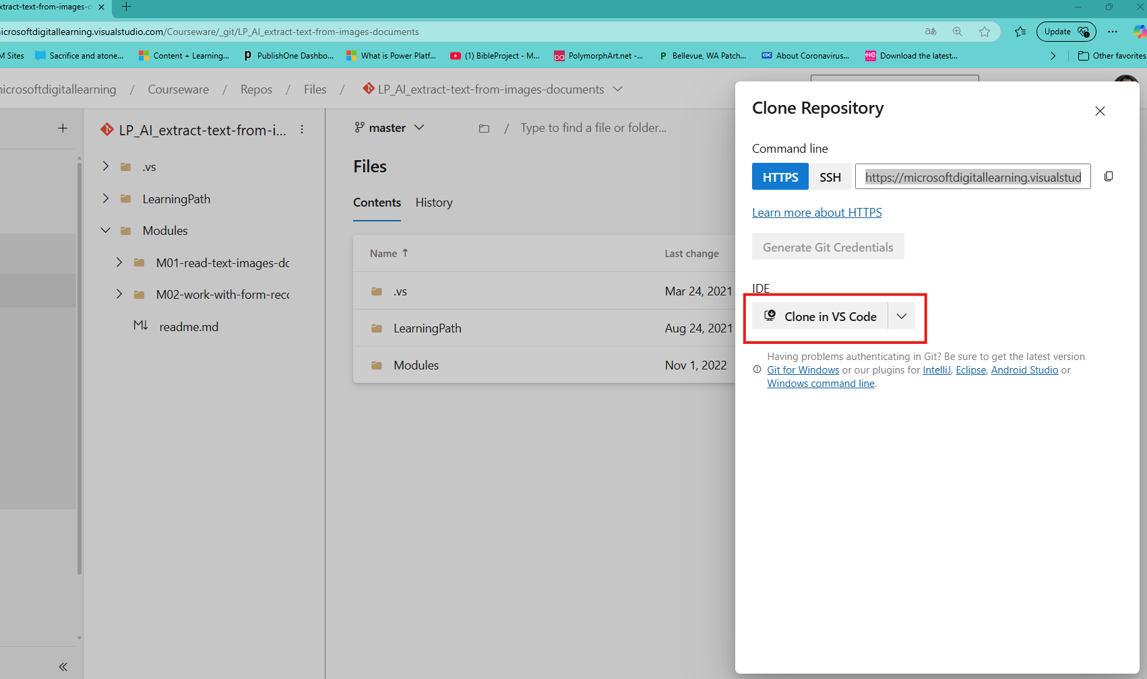

1. Click Open, to Open VS Code

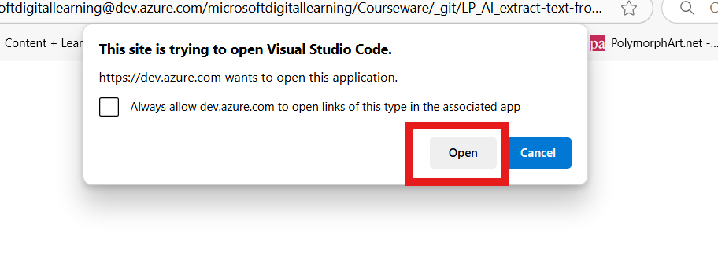

1. System will open VS Code and then pump out window, ask you to designate a local folder to store cloned repo. Choose existing folder or create new folder ,then click “Set as Repository Destination” button.

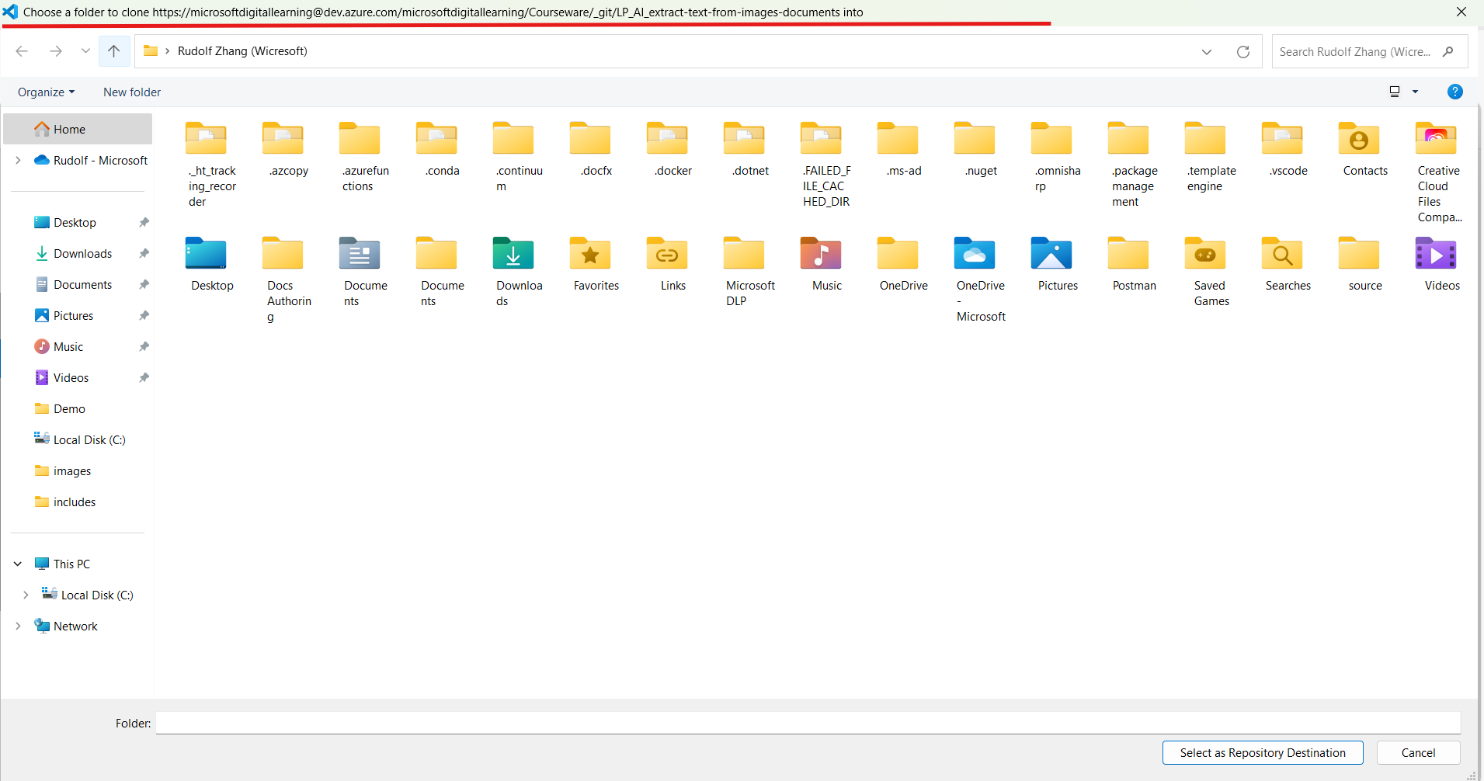

1. System will start clone the repo. When clone finished, system will pump out a window. Click “Open in New Window”

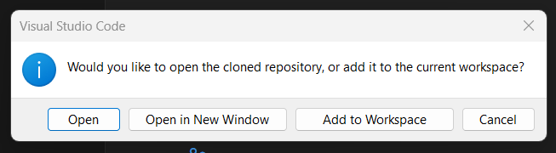

1. In VS code, Click **Source control**, Click **branch name** to switch to branch which contains content.

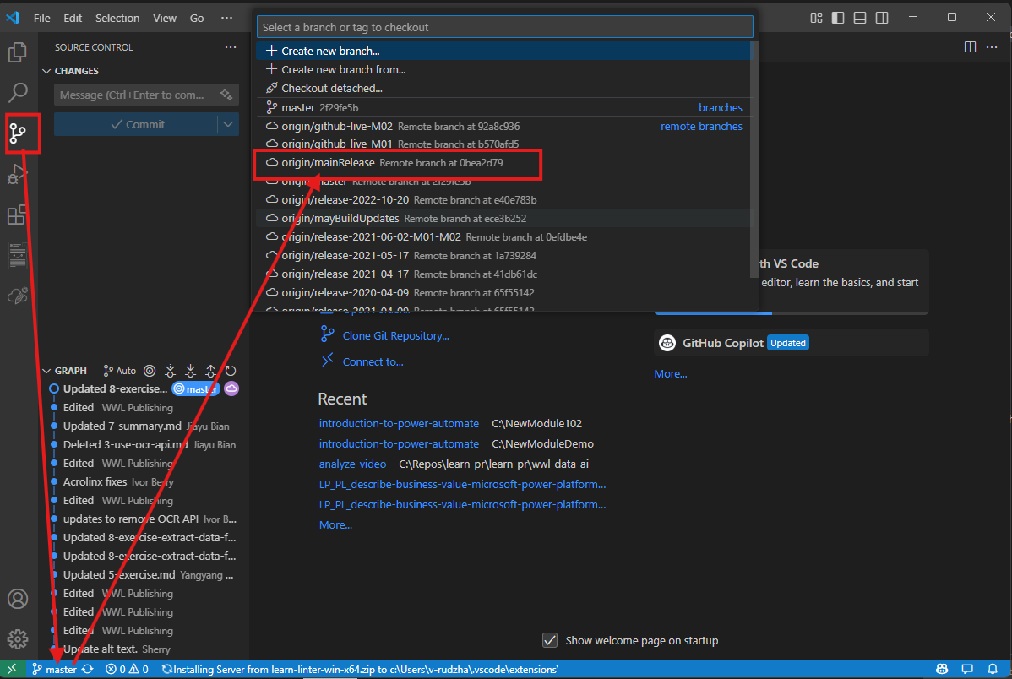

1. Click Explorer and then Right click the Module folder you want to revise. Select AI-Powered Module Creationà Open a module.

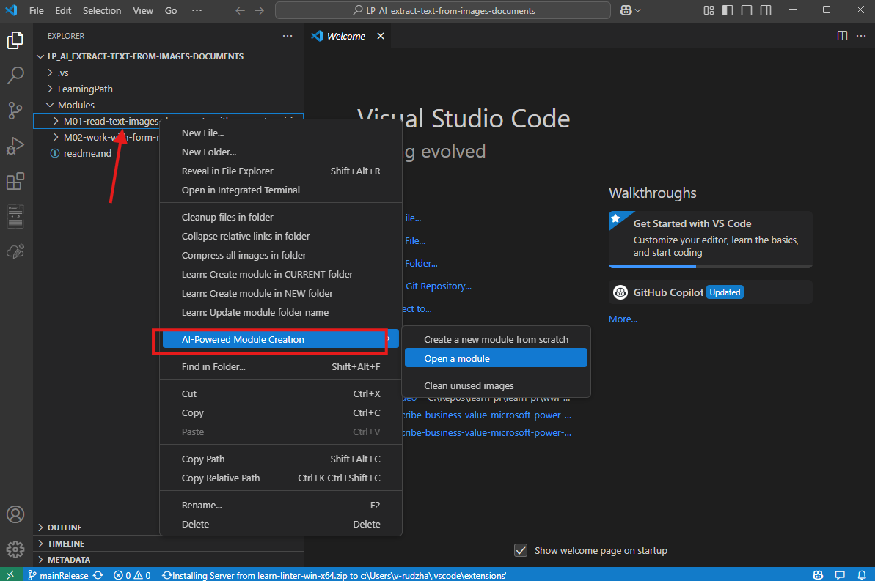

1. System will prompt that it is the extension will create profile for your module. Click **OK** to start this process.

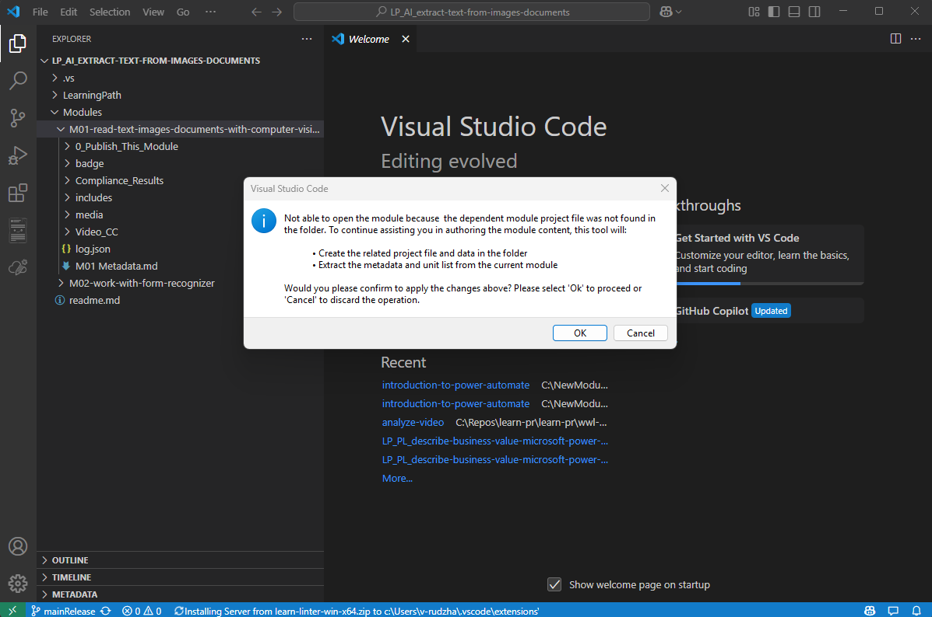

1. System will enter Module Design and then fill in product/Level and Role

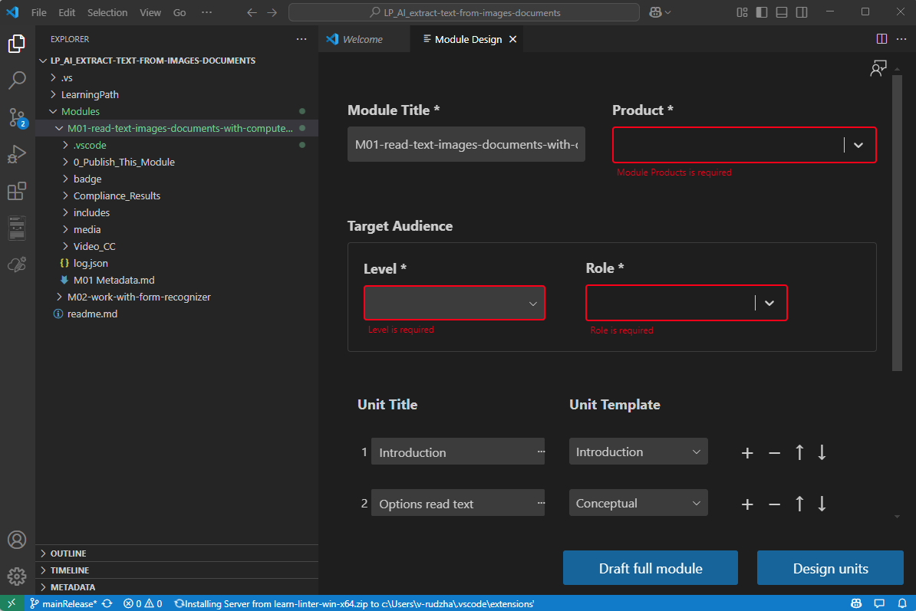

1. Click **Design Units**.You will see all units in generated status.If you want to regenerate a Unit. You could manually add datasource and Unit topics to draft a unit. Or if you want to revise a unit, just close Module designer and then open specific Unit. Then you can revise content with extension’s Content Refine Assistant.

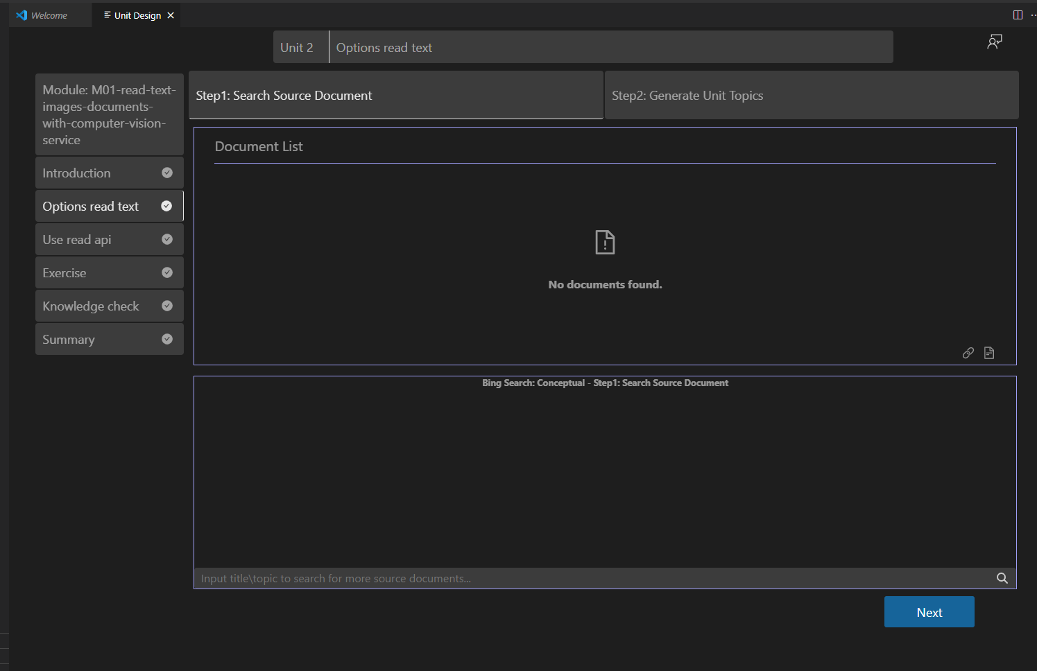

1. After all editing is done, push content update in VS code and then you can continue same pub2learn publishing process.

### Update Module from AI-Powered Module (Pub2Learn )

Sometimes you might want to start editing module folder insider local repo folder directly. Rather than add whole repo into VS Code. To do this you need to follow below steps.

1. Open VS Code,Click Manage (Gear icon) and click Settings.



1. Type in git.open and you will see a control Git:open Repository folders.

Select **always**. This will ensure VS Code edit always seek git configuration even if you open partial folder of whole repo



1. Open Extension and click **Open a Module**.



1. System will pump out **Please select the Module folder** dialogue box. Click folder and click **Open**.

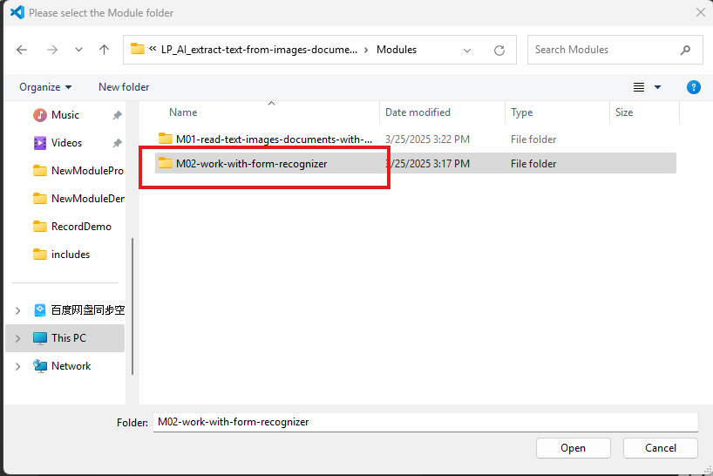

1. You can do any editing works,

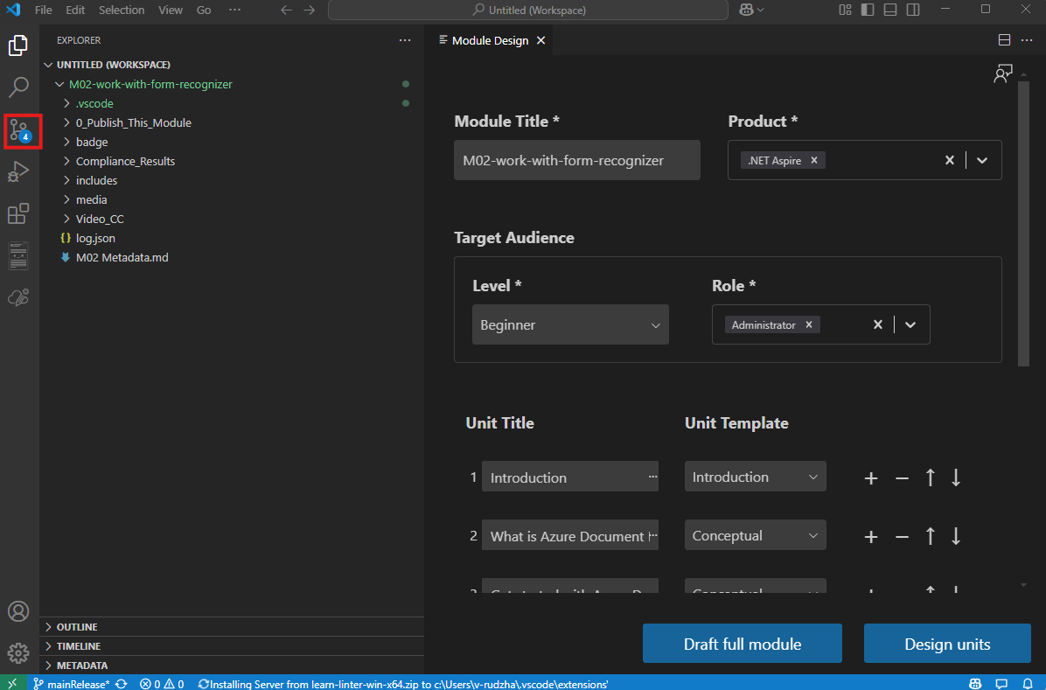

And you can find any editing works will be recorded by Git Repo. Just commit and sync. You will publish changes to remote repo.

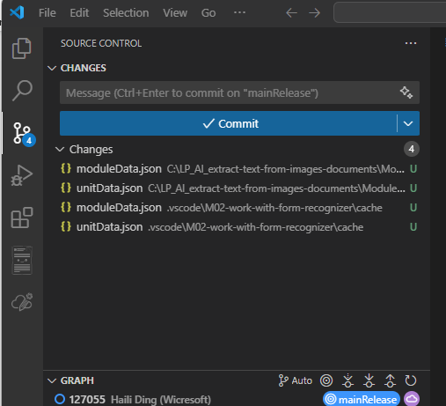

## Authoring Tips

### Q: Are preview-only Learn docs supported as source documents ?

A: AI-Powered Module Creation cannot read documents that don't have public viewing permissions. However, authors can save the content as a Word document and attach it as a datasource.

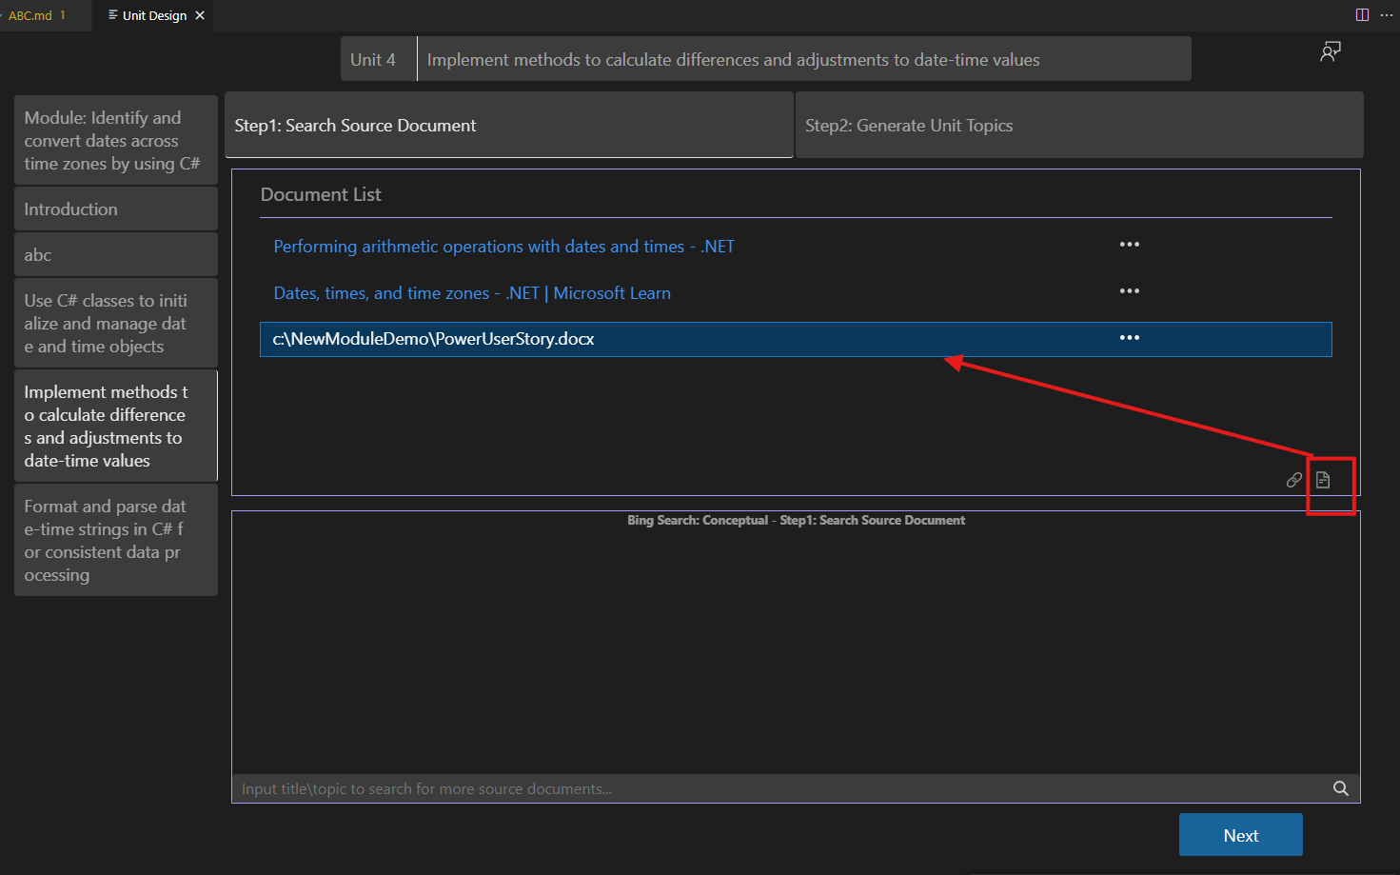

### Q: How to rename a Module folder ?

A: To rename a Module folder, you need to rename 2 folders.

1. Rename the module folder. Right click folder name and select Rename. Rename to new name.

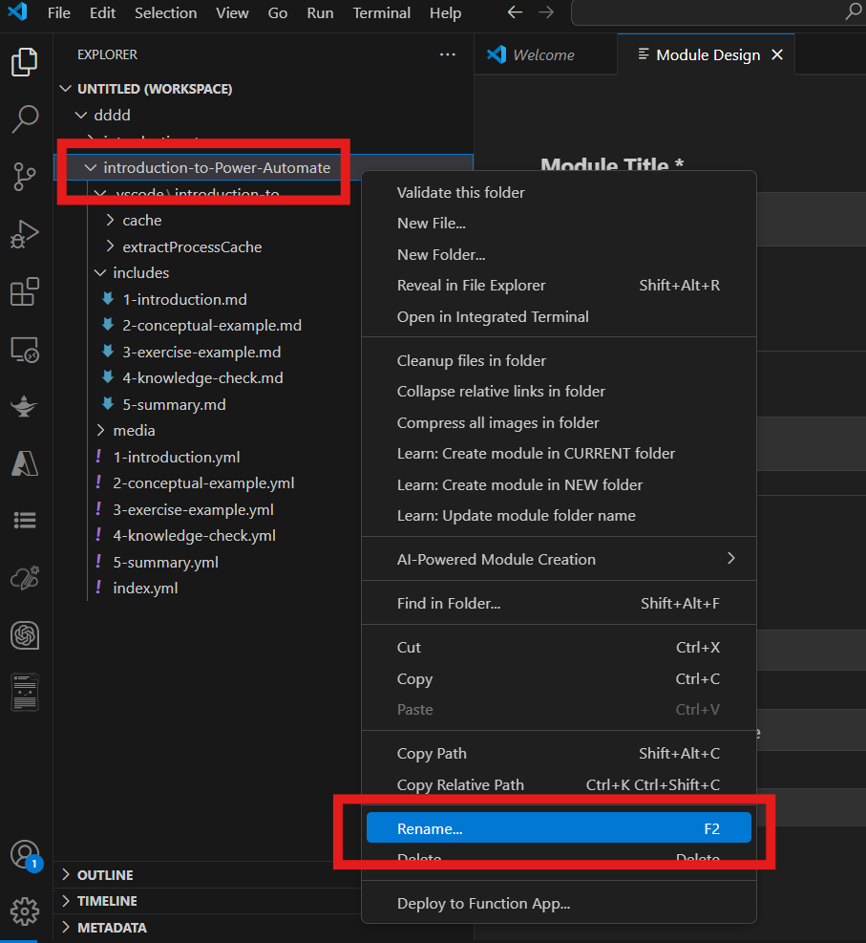

1. Rename the project file folder under .vscode to new name too. Right click folder name and select Rename. Rename to new name which is the same to module folder.

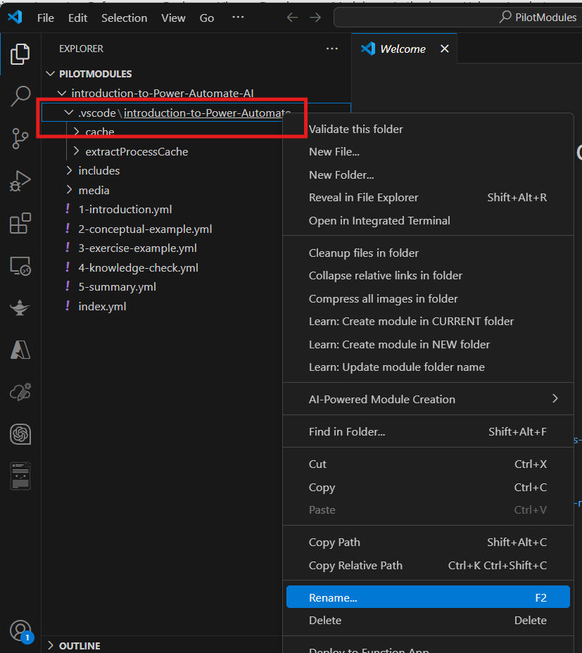

1. And the 3rd place needs to be changed. Open file under  ***ModuleName***/.vscode/***ModuleName***/moduleData.json

Change **locationPath**： to your module foldername

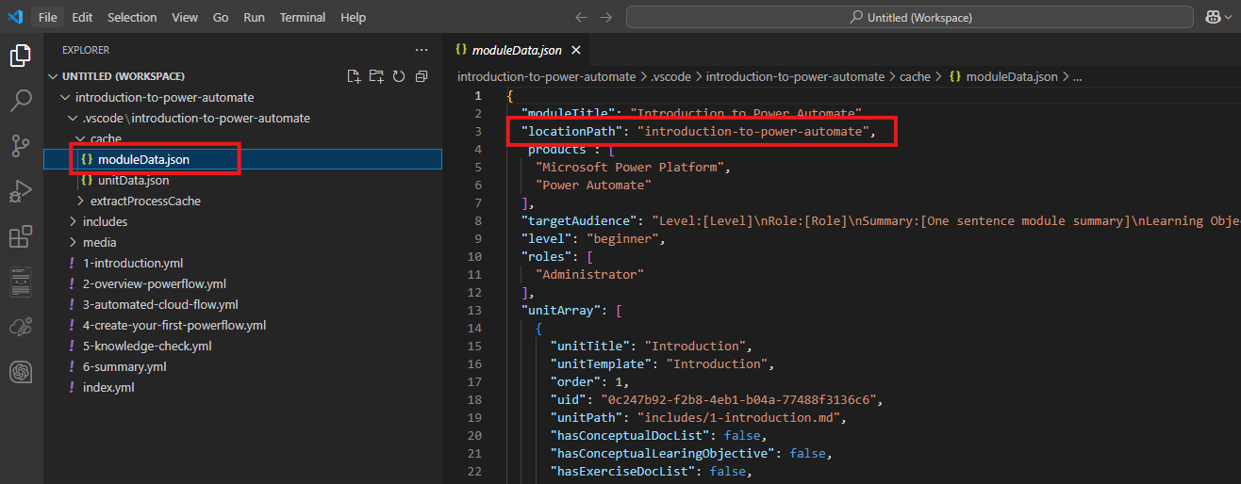

1. Right click renamed module folder name, Select AI-Powered Module Creation àOpen a Module. Reload the renamed module.

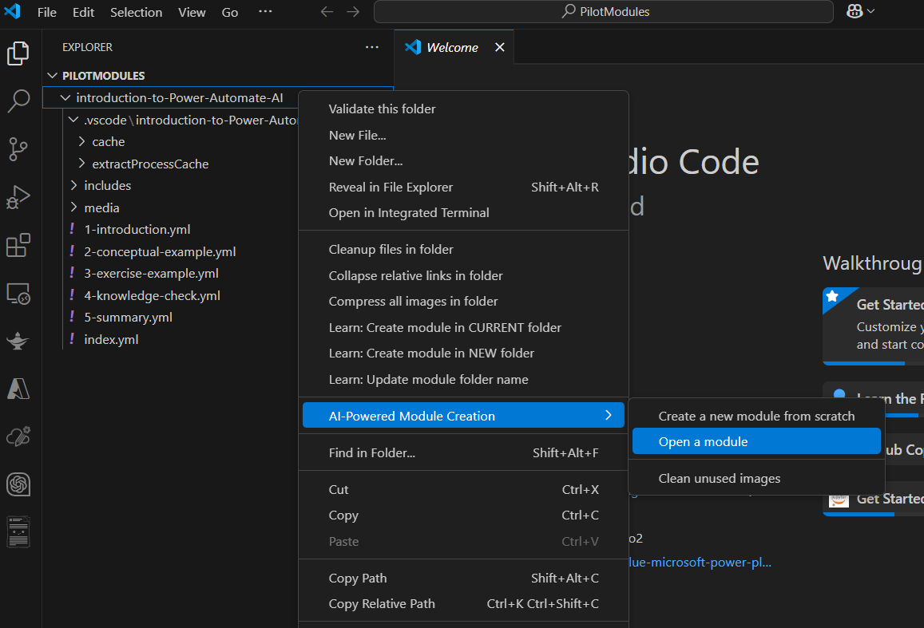

### Q: When updating a module with manually added unit, like 2a-new.md to avoid redirection. How to insert a unit manually in tools ?

A: You can leverage module designer to do this.

For example, we have a manually added 2a-new.md

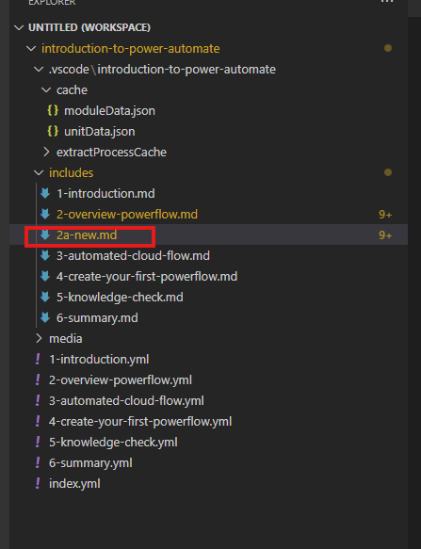

Right click module folder, select AI Powered Module creation,Open a Module. Click + to add a unit.

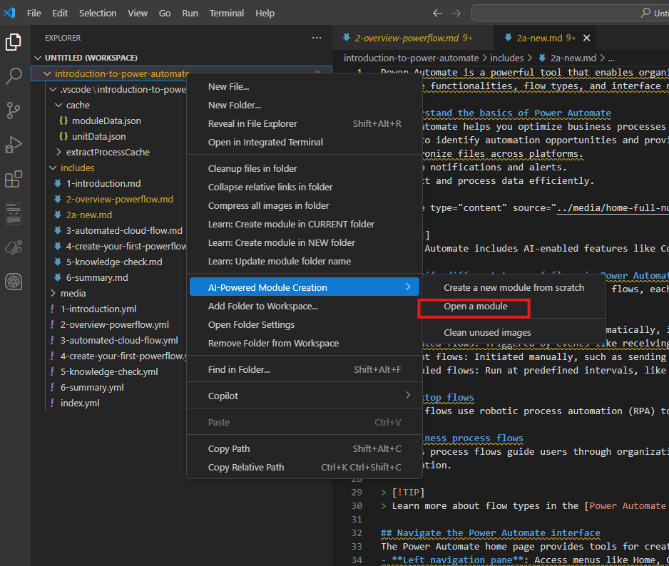

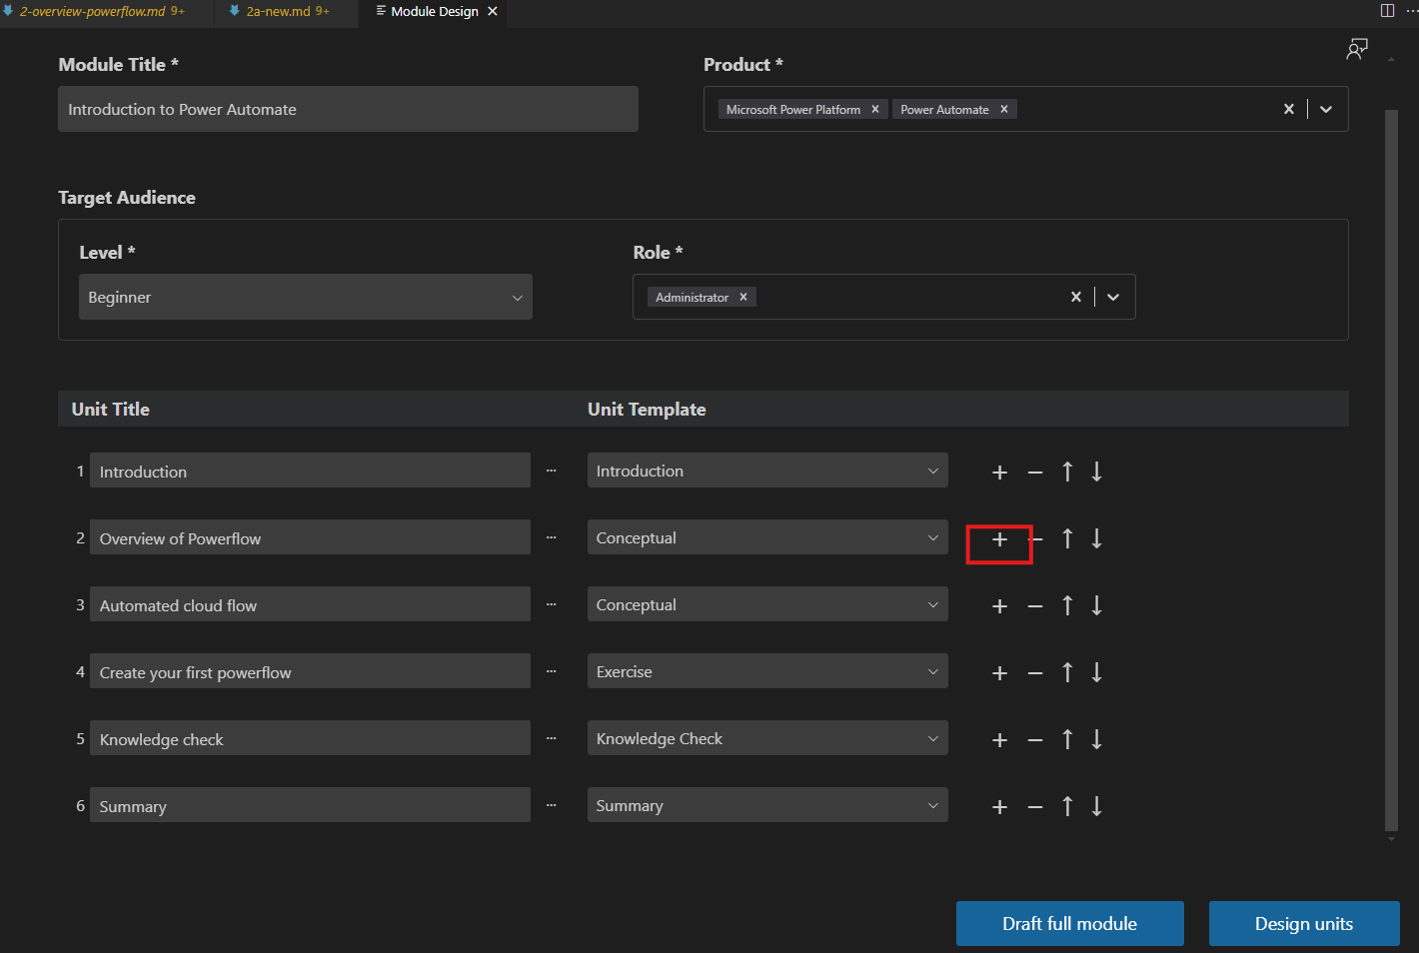

Type in the new Unit title. And click … to link to new unit to 2a-new.md

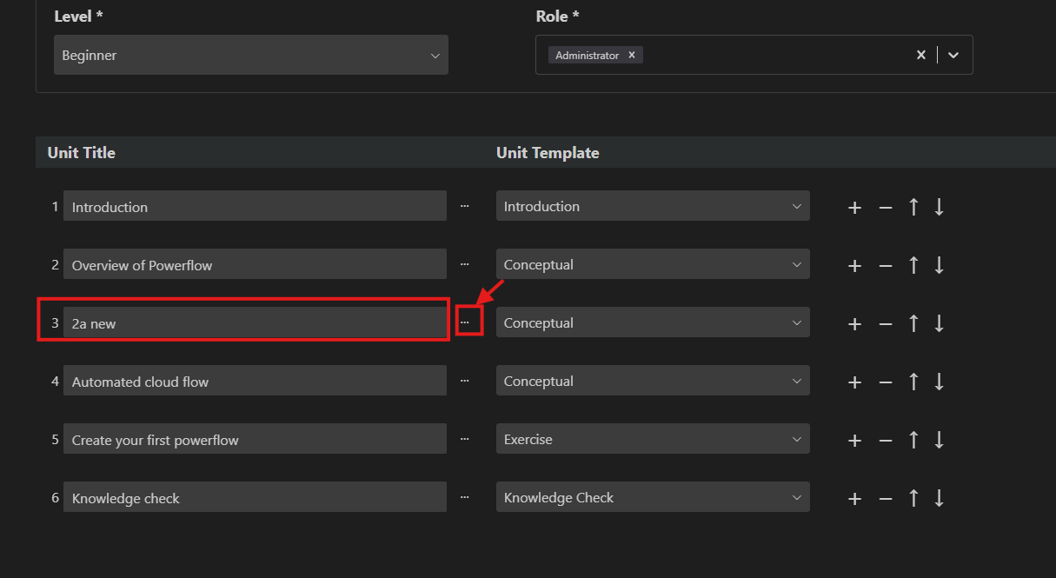

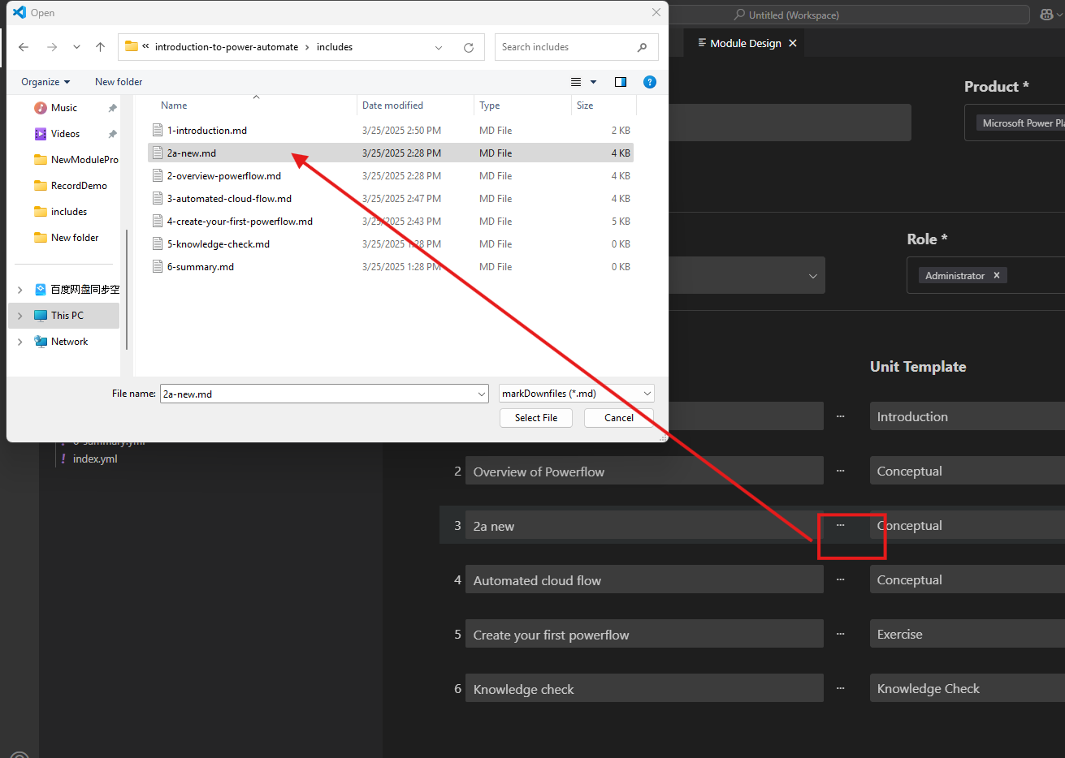

And then relink rest units behind 2a-new.md. Do the same for unit 4,5,6. And then all the links will be fixed.

